**ENTR485**

**Deliverable 3: Business Model Canvas**

**March 15, 2018**

Dani Haboush

Christina Boyle

Brandon Weigand

Christian Slagle

Shoki Kasahara

**Introduction**

In this deliverable, we will begin to shape our business around the new product we are developing. The Therma-Go is portable heat attachment for coffee cup which will allow customers to reheat their coffee anywhere with a simple silicon attachment. In our last deliverable, we presented our research about how our potential customers drink coffee, the price they were willing to pay, and how likely they would be to buy our product. With this information, we were able to better craft our business model canvas, create a business model diagram, analyze our revenue streams, and look deeper into our market size so that we could better prepare a go-to market strategy that communicates our value proposition to our customers.

**Business Model Canvas**

The following graphic is a detailed version of Attachment #1: Business Model Canvas Worksheet.

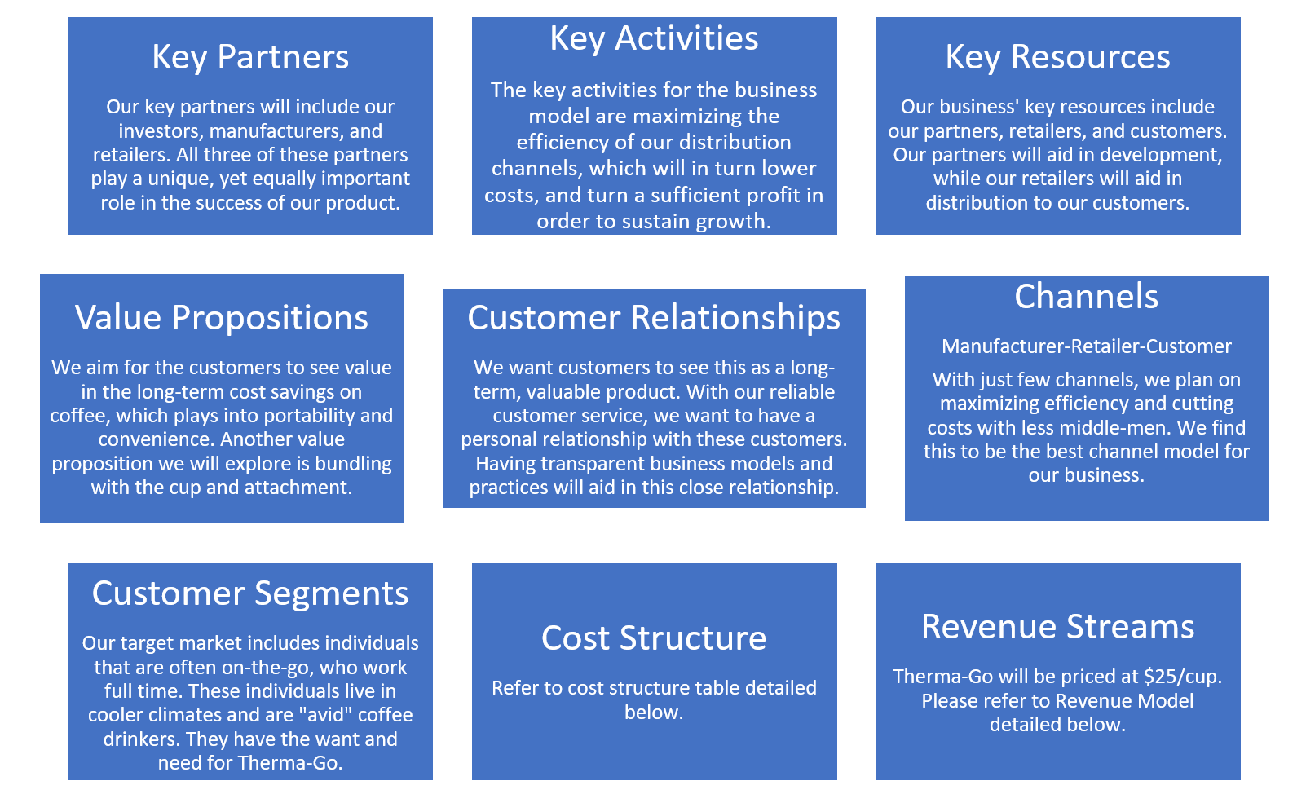

**Business Model Diagram**

The following graphic details Therma-Go’s business model; representing the flow of our product to the customer. First you will notice all the factory Icons, these represent the inflow of the materials we need to make a Therma-Go and for these assets we will be credited cash by these companies. Next, you will notice that we have Amazon and Ebay have a direct flow representing the dead CPU’s we will buy from Ebay and the Rubber we will buy from a supplier on Amazon. Then, you may notice another connection from Amazon and Ebay to Therma-Go this represents the flow of our completed product to using these sites as a selling platform to customers. We believe that from the companies like Ebay and Amazon we will be able to gain more insight and advertising for Therma-Go. Though this method will bring in customers as you can see, we will also have to take a smaller profit margin to cut in the middle men. Finally, you can see the flow of Therma-Go directly selling the product to the customer. From this we will be able to gain data from customer reviews and a higher profit margin than on secondary selling website.

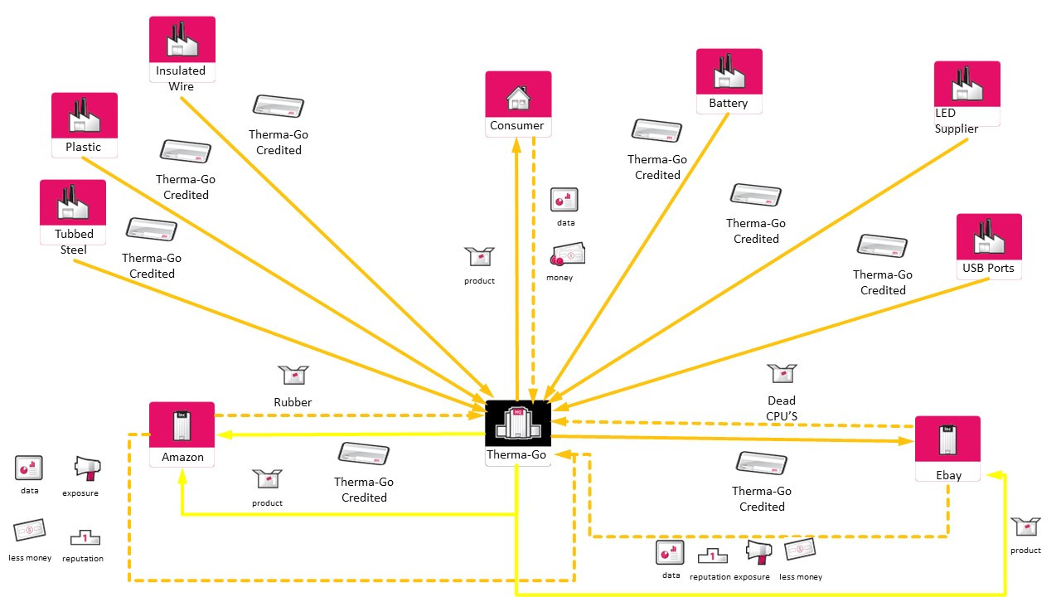

**Revenue Stream**

With Therma-Go, our main revenue stream will be through a Per-Unit revenue model. The per unit cost of each cup will be $17.96 given the information in the table below. With some online research we found that the average retail markup is between 30% and 50% (Ronald L. Bond, 2008), with that in mind we have decided to sell at a profit margin of 29%. This decision will result in our product being priced at $25 before taxes. The initial outflows to kickstart the company will be $17,962.05 for all of the materials and machining necessary to create our product. After obtaining materials, we will contract with our manufacturers to assemble the product.

After production, the product will be sold for $25 each.

|  |  |  |  |
| --- | --- | --- | --- |
| Item | Per Unit price | Total | Units Purchased |
| CPU | 2.0666 | 2,066.6 | 1000 |
| Steel Tube | 1.4969 | 1,496.9 | 1000 |
| Cutting Tube into .75in pieces | 1 | 1000 | 1000 |
| Led | 3.8 | 3,800 | 1000 |
| Housing (plastic) | 2.26 | 2,260 | 1000 |
| Silicone wrapper | 5.64 | 5,640 | 1000+ |
| Battery | 1.39 | 1,390 | 1000 |
| USB Ports | .199 | 238 | 1200 |
| Insulated wire | .0059 | 70.55 | 12000 |
| Total | 17.96 | 17,962.05 | 1000 |

**Value Proposition Canvas**

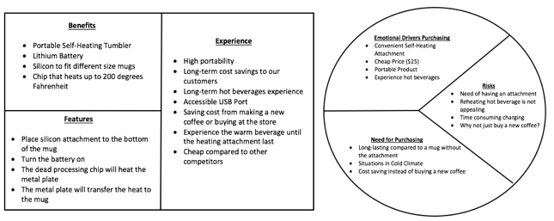

We will be implementing the *Resonating-Focus Approach* into our product design because we prioritize and place the most value on our target customers. Additionally, we would like to constantly collect data from our customers to consistently meet their needs and produce the most optimum product. We are seeking to hear more voices from our customers so that we can intend to meet their demands and even go beyond their expectations.

What are you offering?

Our product, Therma-Go is a portable, self-heating attachment for tumblers to avoid hot beverages from cooling down quickly. We are seeking to establish a strong relationship with our customers and therefore, we have decided to implement the Resonating-Focus Approach to place the highest priority to our customers. With our constant data intake, we will be offering the most ideal product that meets our customer’s demand.

How is it different from somebody else offering the same thing?

We have implemented a lithium battery that allows us to heat the dead processing chip and transfer the heat to the metal plate. This will allow a consistent transform of heat from our attachment to the mug. Additionally, we have created the Per-Unit Revenue Model to offer a cheap and high standard product to our customers. In terms of our price, we are gaining competitive advantage from our competitors.

Who does your offer speak to?

After taking surveys online and collecting data, we have identified our target customers from ages 35 and above. This was because we have identified a positive trend in the number of coffee cups per day and the age. Moreover, we found that customers age 35 and above are the most consistent coffee drinkers.

What does your offer promise to do?

With Therma-Go, the lithium battery ensures a long lasting hot beverage to our customers and can save cost from making or buying a new coffee from the store. Additionally, USB accessible will allow customers to charge our product conveniently because a lot of customers are using smartphones in the current generation.

**Target Customer**

After surveying and collecting data from our customers, we have identified a slight positive relationship between the age and the number of coffee cups per day. Additionally, ages 35 and older are the most consistent coffee drinkers and thus, we have decided to set our target customers from 35 and above. As we have mentioned in our Deliverable 1, our target market are customers that are avid coffee drinkers, those that live in a relatively cold environment and mostly working customers. We will be trying to seek a long-term relationship with our customers by providing valuable and highly efficient product. Offering reliable and consistent customer service will ensure a high brand loyalty.

**Market Size**

Our addressable market size is extremely large, the market is basically anyone who drinks hot beverages that can be considered “on-the-go”. In order to obtain a actual figure, we decided to only target Americans in the workforce, this number is about 126 million people. In conclusion, we have a market size of about 126 million Americans. Even if we are able to capture just one percent of the American workforce, that would be about 1.26 million Americans.

Currently our only competitor we have found is a product called Ember. Ember is a mug that you can control the temperature of your drink using an app on your phone. Our product is superior as it is much more visitile, with ember you get a single mug that is a single size. With ThermaGo, any cup can go inside of the silicon sleeve, eliminating the need for a single cup. This sets us apart as ThermaGo can be used in almost any setting where a hot drink is necessary.

Our product will be interacting with our customer through daily use of the warmer with any cup that the customer owns. The cup has a portable battery in it so all the customer will have to do is charge the attachment while they make their drink and then take it with them after the drink is made. This allows our product to not only be a household item but rather a traveling item.

**Go-To-Market Strategy**

In order to reach our market, we need to establish the marketing aspects of our product, Therma-Go. We began by utilizing the SAVE method as opposed to the 4 P’s of marketing to make sure our marketing strategy is solution driven and customer focused.

|  |  |  |  |
| --- | --- | --- | --- |
| **Solution** | **Access** | **Value** | **Education** |
| Therma-Go is a portable, lithium battery powered attachment that heats coffee in minutes. By providing heat in a sleek and compact form, we eliminate the waste of a daily cup of coffee. | Customers can find this product on amazon.com as well as in a select few local coffee shops. Partners in coffee shops will include places like Cartel Coffee Lab, a place that combines sleek design with a serious love for specialty coffee. | Because a cup of coffee can cool down in under 20 minutes on average, tons of coffee is wasted every day. Whether it’s the perfect cup you brewed at home to the $5 you spent on a Caramel Macchiato, no one likes to throw a lukewarm cup away. Our product combats this issue and provides and easy and long-lasting way to keep your coffee hot. | Our website offers information about the product. Amazon.com also provides details about the product as well as question and answers and reviews from customers. |

To kick-off our product launch, we made a website where customers can learn about how our product works, buy it online, and find places that sell our product. Here is a screenshot of a preliminary version of our website.

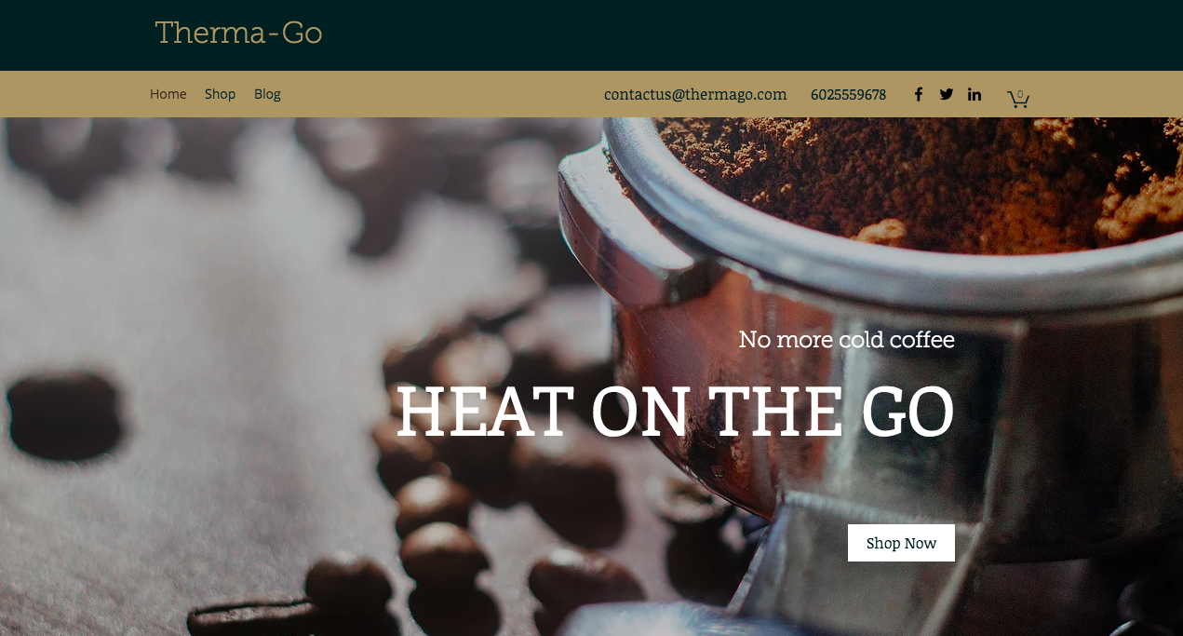

This website will help us when we start our social media campaign to help launch our product. Along with a Therma-go Instagram, Twitter, and Facebook, we will reach out to bloggers that will utilize their following to promote our product. By using popular “Instagrammers,” we can reach different markets directly. For example, a mom blogger and a fitness blogger will have different followings, but both could benefit from the Therma-Go solution. We will reach out to as many as 100 popular Instagram personas and hope to have at least 50 promote our product to their millions of followers based off the incentive of receiving the product for free.

In addition to our website, we also plan to sell our product via Amazon. Using Amazon helps us market our product through the suggestions that Amazon provides its customers who are buying coffee related products like filters, mugs, and coffee makers. Amazon is one of our most important partners because they provide a medium to distribute our product and advertise at the same time.

Our most reliable early adopters are “Amazon addicts.” In other words, we want to reach people who are tempted by one-click purchases and free two-day shipping. As long as Amazon suggests our product, and ads on other websites directing them to the Amazon site appear, this group of early adopters will be interested enough to try a new product. “Portable Beverage Heater by Therma-Go” will be what appears as the product title on Amazon with a sleek photo to go along with it.

To acquire customers we plan use entrepreneurial marketing to get the word out about our product develop relationships with our customers. This involves spreading information through word of mouth and social media rather than flooding potential customers with advertisements. Although online advertisements are important, we want to target people who are most likely to try this new product. We can find these people through their interests on social media and seeing who they follow. Once the early adopters are targeted, word of mouth will create a customer base strong enough to make a profit.

**Conclusion**

To conclude, this deliverable has provided a better understanding of our product Therma-Go and has outlined some key factors such as the overall business model including the main revenue stream as well as the value proposition of our product. With our entrepreneurial marketing style, we will attract more customers to buy our product and provide a strong and loyal relationship with our buyers.

**Attachments**

**1**

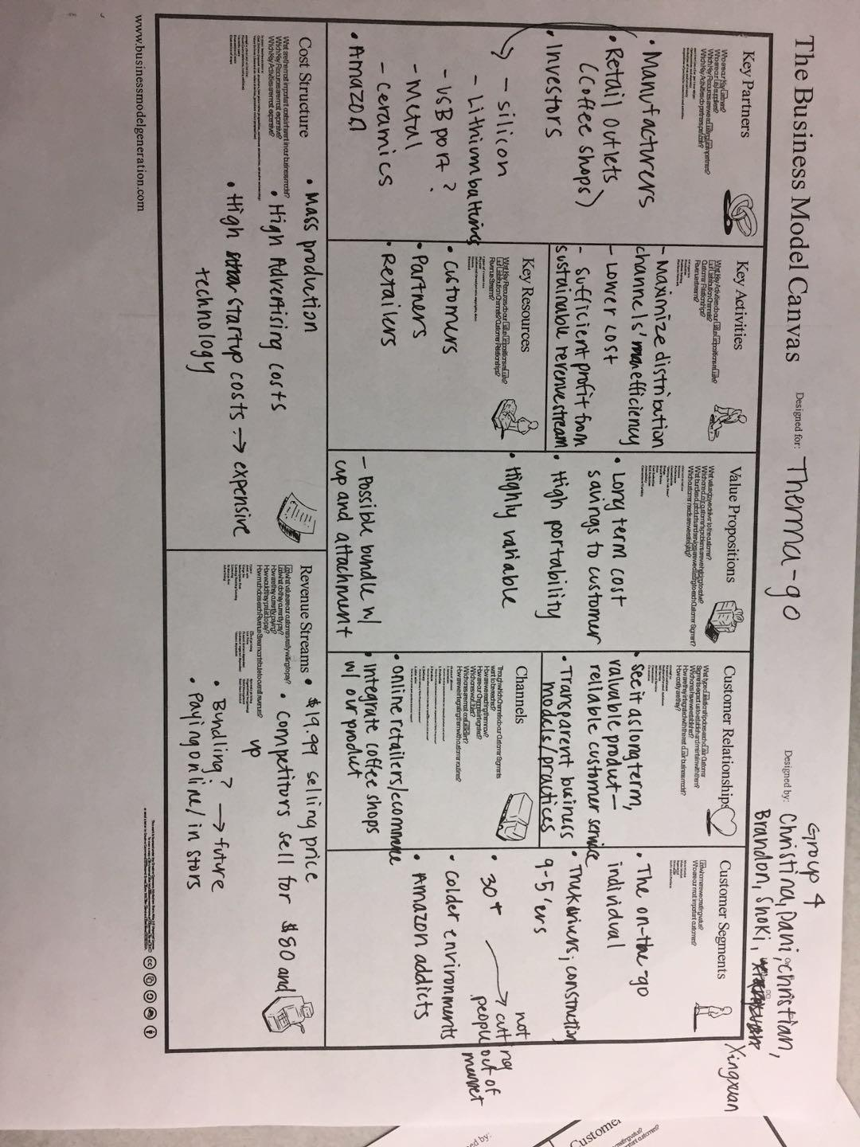

**References**

1. All products require an annual contract. Prices do not include sales tax (New York residents only). (n.d.). U.S. full-time employees: February 2018 unadjusted | Statistic. Retrieved March 15, 2018, from https://www.statista.com/statistics/192361/unadjusted-monthly-number-of-full-time-employees-in-the-us/
2. Amazon. “SBR (Styrene Butadiene Rubber) Sheet, 70 Shore A, Black, Smooth Finish, No Backing, 0.062’ Thickness, 4’ Width, 36’ Length: Industrial & Scientific.” *Amazon.com: SBR (Styrene Butadiene Rubber) Sheet, 70 Shore A, Black, Smooth Finish, No Backing, 0.062" Thickness, 4" Width, 36" Length: Industrial & Scientific*, Amazon, 2018, [www.amazon.com/gp/product/B00L8NRV2S/ref=s9_acsd_topr_hd_bw_bCI3IjD_c_x_w?pf_rd_m=ATVPDKIKX0DER&pf_rd_s=merchandised-search-3&pf_rd_r=43T6H50581ZB7XVZTE72&pf_rd_t=101&pf_rd_p=1a8d1c64-fcac-5eb9-a3b8-8ac6369b0e0d&pf_rd_i=11260355011.](http://www.amazon.com/gp/product/B00L8NRV2S/ref=s9_acsd_topr_hd_bw_bCI3IjD_c_x_w?pf_rd_m=ATVPDKIKX0DER&pf_rd_s=merchandised-search-3&pf_rd_r=43T6H50581ZB7XVZTE72&pf_rd_t=101&pf_rd_p=1a8d1c64-fcac-5eb9-a3b8-8ac6369b0e0d&pf_rd_i=11260355011.)
3. Cable Wholesale. “1000ft Yellow Zipcord Singlemode Duplex Fiber Optic Cable.” *CableWholesale.com*, Cable Wholesale, 15 Mar. 2018, [www.cablewholesale.com/specs/10f1-001nh.php?utm_source=GoogleShopping&utm_medium=cpc&utm_term=10F1-001NH&utm_campaign=Bulk Zipcord Fiber Optic Cable, Singlemode, Duplex, 9/125, Yellow, Riser Rated, Spool, 1000 foot&gclid=EAIaIQobChMI0oDhxbTo2QIVFIh-Ch0ZQgwEEAQYBCABEgKyuvD_BwE.](http://www.cablewholesale.com/specs/10f1-001nh.php?utm_source=GoogleShopping&utm_medium=cpc&utm_term=10F1-001NH&utm_campaign=Bulk)
4. Ebay. “Wholesale 10- 1000pc WS2812B 5050 RGB LED &PCB Board 1-LED Module Pixel Light 5V.” *Wholesale 10- 1000pc WS2812B 5050 RGB LED &PCB Board 1-LED Module Pixel Light 5V | EBay*, Ebay, 2018, [www.ebay.com/i/321716625422?chn=ps](http://www.ebay.com/i/321716625422?chn=ps).
5. Garland Computer. “5 Lbs Pinned/Pinless AMD Opteron Intel Xeon CPU Processors Scrap Gold Recovery.” *EBay*, Ebay, 2018, [www.ebay.com/itm/5-lbs-Pinned-Pinless-AMD-Opteron-Intel-Xeon-CPU-Processors-Scrap-Gold-Recovery-/292449501012?hash=item4417593f54.](http://www.ebay.com/itm/5-lbs-Pinned-Pinless-AMD-Opteron-Intel-Xeon-CPU-Processors-Scrap-Gold-Recovery-/292449501012?hash=item4417593f54.)
6. Metals, Online. “Cold Finish Stainless Round 316/316L.” *2" T-316 Stainless Round Rod - Online Metal Store*, 2018, [www.onlinemetals.com/merchant.cfm?pid=4489&step=4&showunits=inches&id=7&top_cat=1](http://www.onlinemetals.com/merchant.cfm?pid=4489&step=4&showunits=inches&id=7&top_cat=1).
7. Mouser. “10118193-0001LF Amphenol FCI | Mouser.” *Mouser Electronics*, Mouser, 2018, [www.mouser.com/ProductDetail/FCI-Amphenol/10118193-0001LF/?qs=Ywefl8B65e63Nsqd+8HZaQ==&gclid=EAIaIQobChMIoq-Y3LPo2QIVEbnACh3MNg5GEAQYAiABEgKhVfD_BwE](http://www.mouser.com/ProductDetail/FCI-Amphenol/10118193-0001LF/?qs=Ywefl8B65e63Nsqd+8HZaQ==&gclid=EAIaIQobChMIoq-Y3LPo2QIVEbnACh3MNg5GEAQYAiABEgKhVfD_BwE).
8. Peng, Amy. “Wholesale Cell Phone Batteries.” *Wholesale Cell Phone Batteries in Cell Phone Accessories - Buy Cheap Cell Phone Batteries from Cell Phone Batteries Wholesalers | DHgate.com*, DHgate, 2018, [www.dhgate.com/wholesale/dirlist.do?searchkey=&catalog=105005010&searchSource=sort&uuid=0441674919&stype=up&sinfo=price&shipcountry=us&isadvanced=0&advancedno=&luceneQuery=&seotype=&thirdattr=&_flush=970637952](http://www.dhgate.com/wholesale/dirlist.do?searchkey=&catalog=105005010&searchSource=sort&uuid=0441674919&stype=up&sinfo=price&shipcountry=us&isadvanced=0&advancedno=&luceneQuery=&seotype=&thirdattr=&_flush=970637952).
9. Bond, R. L. (2008, May 25). Finding the Right Price for Your Retail Products. Retrieved March 13, 2018, from https://www.entrepreneur.com/article/193986
10. Master Caster. “Grommet, Desk, 2 In Dia, 1 1/8 In H, Blk.” *Zoro the Fox*, Zoro, 2018, [www.zoro.com/master-caster-grommet-desk-2-in-dia-1-18-in-h-blk-00201/i/G2090295/feature-product?gclid=EAIaIQobChMIh5yG9rLo2QIVR7bACh3hMg5vEAQYAiABEgL69vD_Bw](http://www.zoro.com/master-caster-grommet-desk-2-in-dia-1-18-in-h-blk-00201/i/G2090295/feature-product?gclid=EAIaIQobChMIh5yG9rLo2QIVR7bACh3hMg5vEAQYAiABEgL69vD_Bw).